**Sprint Goal:** Basic front-end for creating and animating Cellular Automata.

**Spikes:**

* Spike 1: Cellular automata research
* Spike 2: Material UI and react components.
* Spike 3: GPU shader research in p5.js
* Spike 4: Javascript node research
* Spike 5: UX design

**User story tasks:**

* **User story 1 (animated):** As a viewer, I want to view animated cellular automata, so that I can observe emergent behavior.
  + Task 1: GPU shaders for cellular automata. (2 hours)
  + Task 2: p5.js react component to interact with shaders (1 hour)
  + Task 3: 1D CA in 1D (3-5 hours)
  + Task 4: 1D CA in 2D (3-5 hours)
  + Task 5: 2D CA in 2D (3-5 hours)
  + Total time: 15 hours
* **User story 2 (premade):** As a viewer, I want to use premade CA rulesets, so that I can look at surreal visuals with minimal effort.
  + Task 1: Material UI barebones interface/layout (4 hours)
  + Task 2: create of a list of desired rulesets (1 hour)
  + Total time: 5 hours
* **User story 3 (fullscreen):** As a viewer, I want to enable full screen so that I can look at surreal visuals alone.
  + Task 1: Material UI button to hide UI (1 hour)
  + Total time: 1 hour
* **User story 4 (pen):** As a viewer, I want to populate cells with arbitrary mouse movements so that I can look at surreal visuals without having to come up with a complicated initial state.
  + Task 1: Material UI button to activate pen mode (1 hour)
  + Task 2: Map mouse movements into p5 then into the shader. (1 hour)
  + Task 3: Change cursor to pen shape (1 hour)
  + Total time: 3 hours
* **User story 5 (zoom) :** As a builder and viewer, I want to zoom into the page, so that I can see cellular automata up close and edit their initial states with precision.
  + Task 1: scale pixels in correspondence with zoom (8 hours)
  + Total time: 8 hours

**Team Roles:**

Kevin Schultz: Product Owner

Ethan Foster: Scrum Master

Preston Nguyen: Team Member

Alexander Garza: Team Member

Beckett Avary: Team Member

**Initial Task Assignment:**

Kevin Schultz: User Story 1 (animated), User story 5 (1D_in_1D), User story 6 (1D_in_2D)

o

Ethan Foster: User Story 4 (pen), User Story 5 (1D_in1D), User Story 6 (1D_in_2D)

Preston Nguyen: User Story 2 (premade) User Story 3 (fullscreen), User Story 4 (pen)

Alexander Garza: User Story 2 (premade), User Story 6 (1D_in_2D)

Beckett Avary: User story 7 (2D_in2D), User story 8 (shader_lang)

**Burnup chart:**

**Prioritized user stories**

1. animated
2. 1D_in_1D
3. Premade
4. Fullscreen
5. 1D_in_2D

**Backlog**

1. 2D_in_2D
2. Pen
3. shader_lang

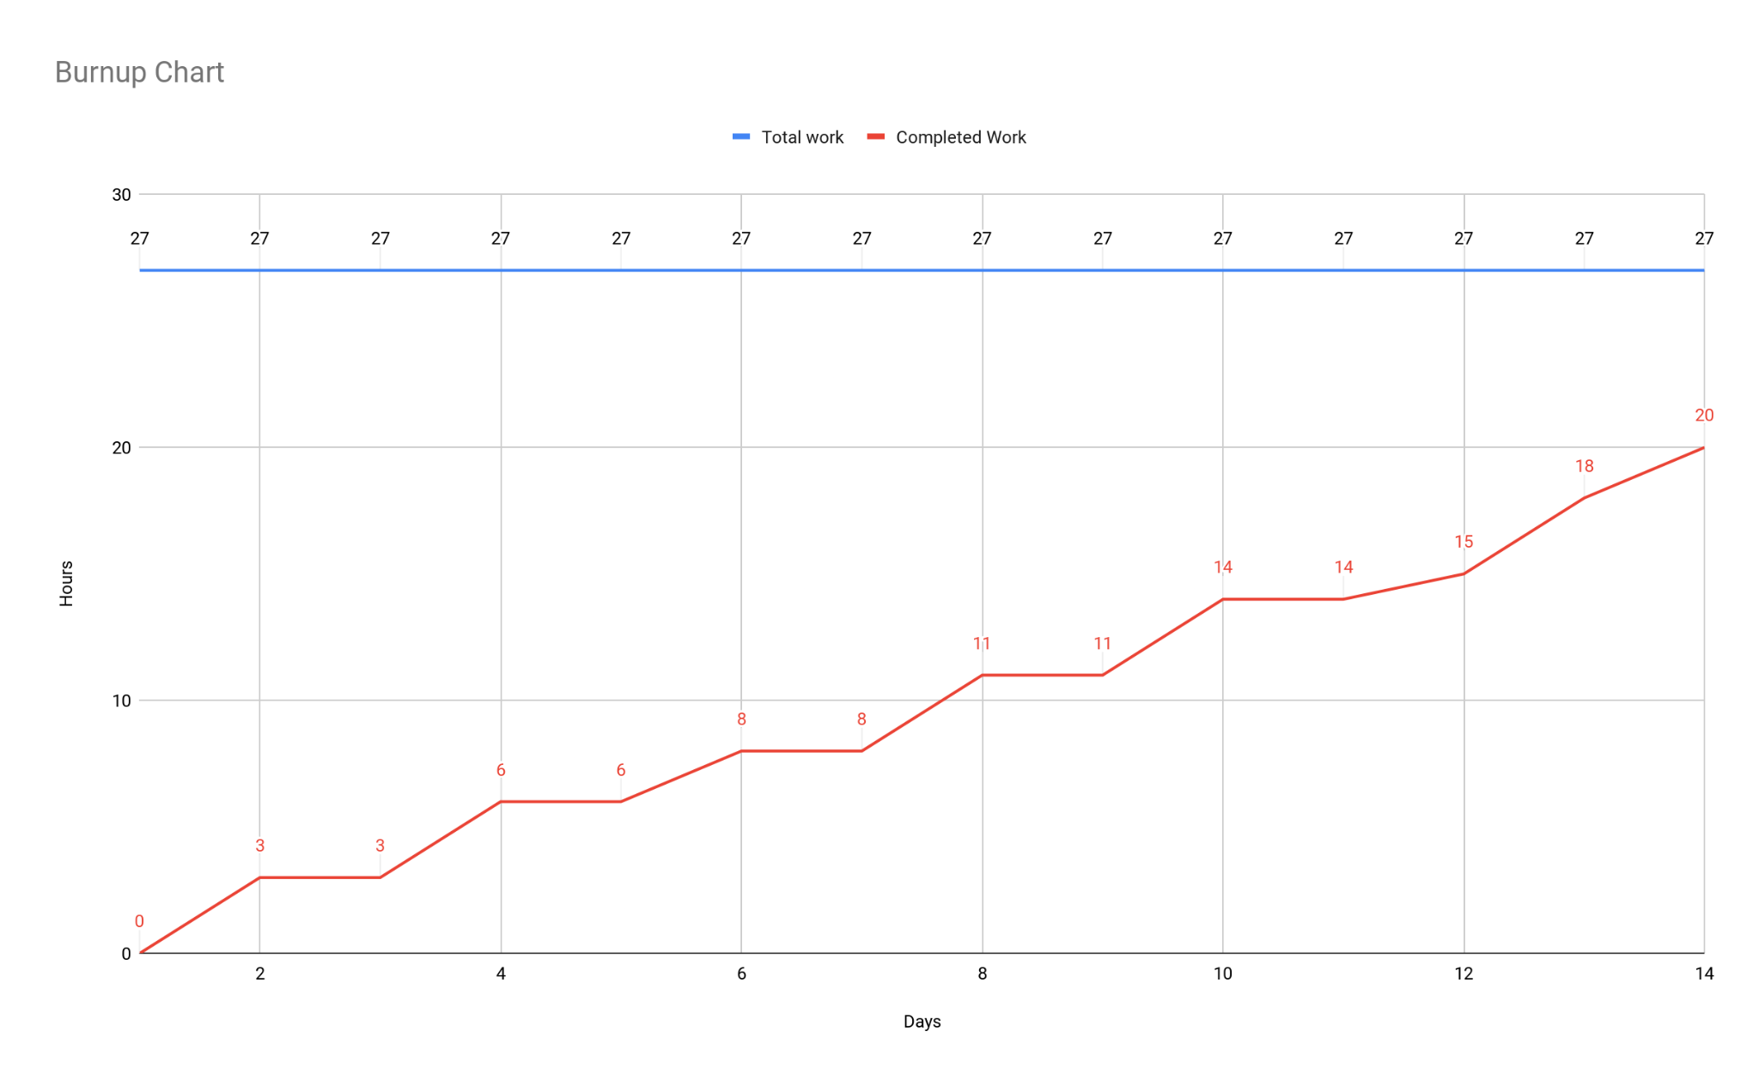**Scrum Board:**

<https://jamboard.google.com/d/1WuecReEvjC3s1jhugJyICtRss0PQq9s4udIiGU8Cr9I/edit?usp=sharing>

**Scrum meeting times:**

Mon: 3:00

Wed: 4:00

Fri: 3:00